1-
DELIMITER $$

CREATE PROCEDURE `insertar`( in cedula varchar(15), nombre varchar(15), apellido varchar(15))
BEGIN
INSERT INTO clientes VALUES (cedula, nombre, apellido);

END
$$
DELIMITER;

2-
DELIMITER $$

CREATE PROCEDURE `actualizar`( in Ncedula varchar(15), Nnombre varchar(15))
BEGIN
UPDATE nombre SET nombre=Nnombre WHERE cedula=Ncedula ;

END
$$
DELIMITER ;

3-
DELIMITER $$
CREATE PROCEDURE `Borrar`(in Ncedula varchar(15))
BEGIN
DELETE FROM clientes WHERE cedula=Ncedula;
END $$
DELIMITER ;

4-
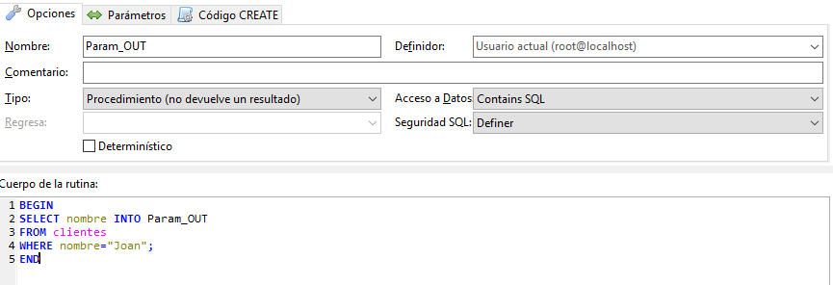

5-
